Cairo University Faculty of Computers and Artificial Intelligence



**Advanced SE**

**Software design specification document**

**2022**

**Project Team**

|  |  |  |
| --- | --- | --- |
| **ID** | **Name** | **Email** |
| 20201183 | Mayar Mohamed | mayarmohamedhamed12345@gmail.com |
| 20200595 | Nadeen Badr | nadeenbadr0@gmail.com |
| 20200732 | Yasmeen samy | Yassmeensamy1@gmail.com |

# 

# Class diagram design

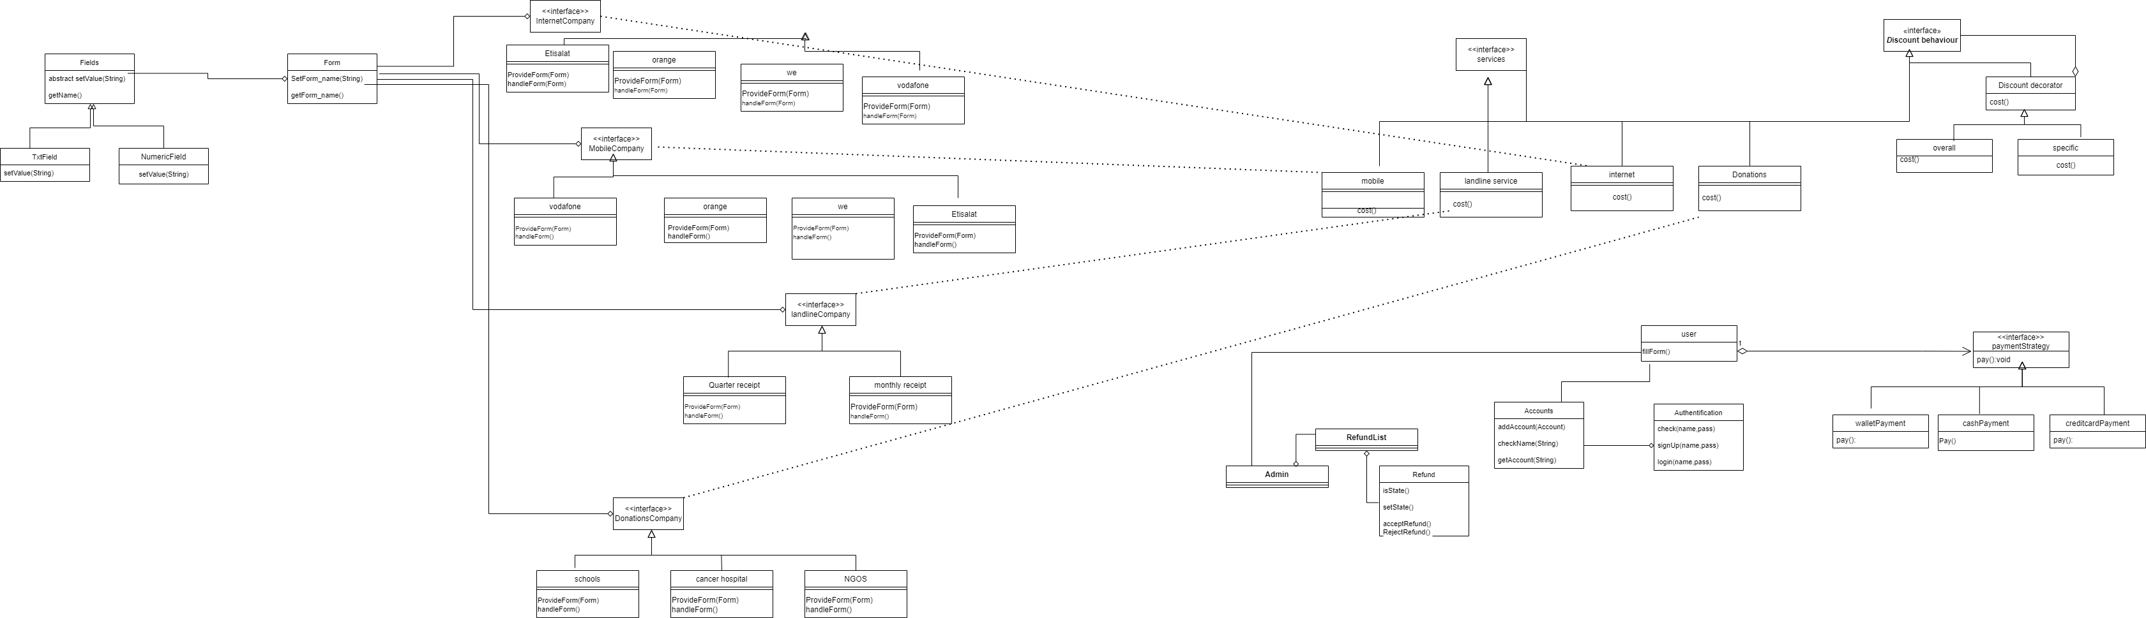

# Class diagram Explanation

* **Discount ->Decorator** because overall discounts and specific discounts for this service may apply at the same services or provider.
* **Services ->Factory** to create different providers
* **Payment ->Strategy** because it is same action but different way to do.
* **Forms ->Factory** to create different fields

# Sequence diagram design

* **Discount**

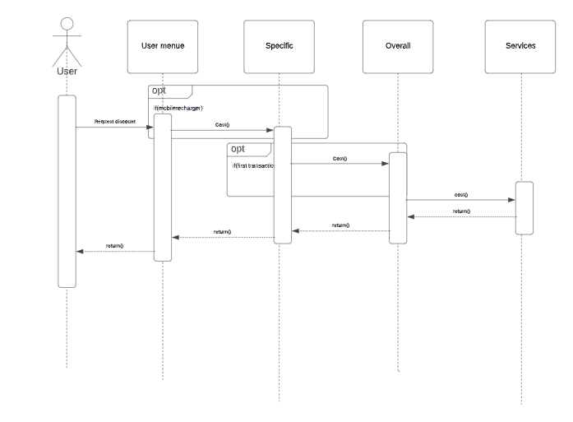

* **Refund List**

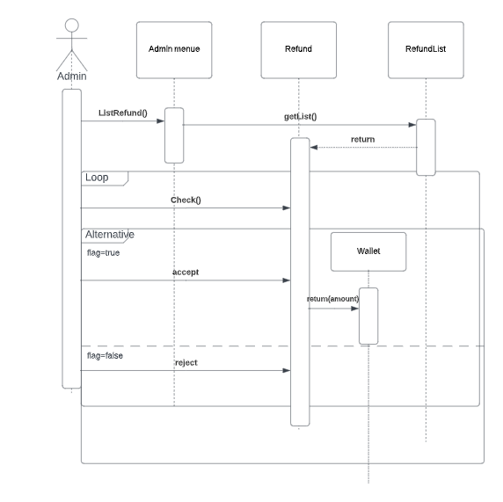

* **Payment**

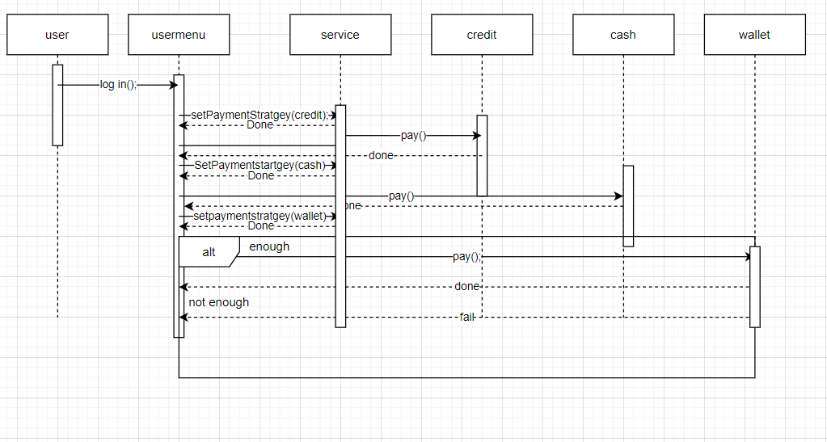

* **Log in**

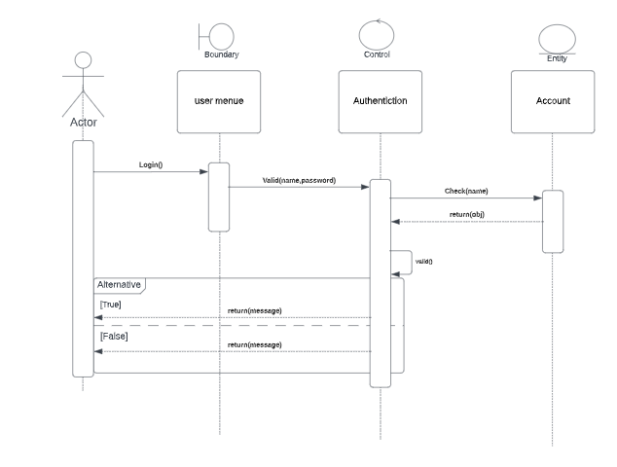

* **User Refund**

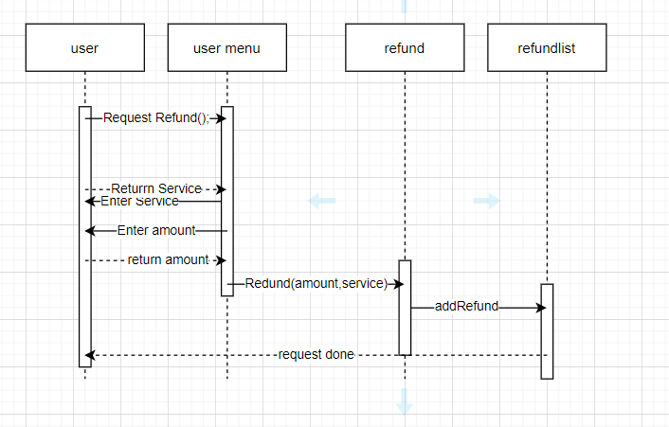

* **Search**

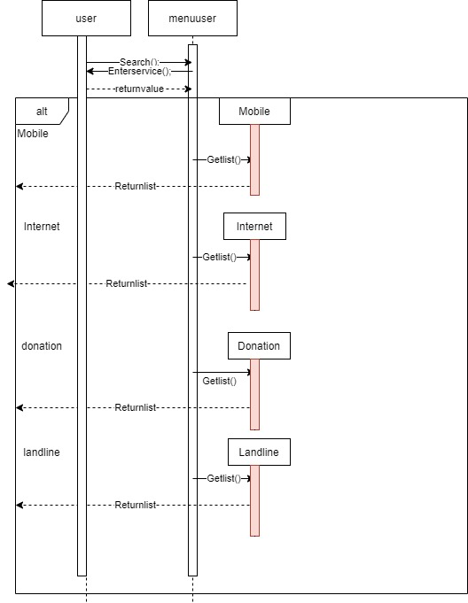

# Github repository link

* **URL for your repository, should contains implemented services**,